CERTIFICATION FOR PAYMENT

This is to certify that Loka Design Studio (print name of tenant/resident) meets the definition of “sim tint” in Webpage content developing

**Type of the applicant:** Foreign Corporation **Name of the applicant:** Loka Design Studio **Address of the applicant**:

Vía de las dos Castilla 9

Pozuelo de Alarcón

Madrid

Spain

**Name of Project:** sim tint

# Description:

Sim tint Development (9/19 – 9/22)

**Amount**: $ 202.21 USD

**Tax :** -$ 9.20 USD

Total : $ 193.01 USD

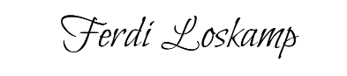

# Signatures:

**Owner/Managing Agent:** Ferdi Loskamp **Date:** Sep 22, 2023

Project detail Description

Mr Zhao tiezhu:

Zhao tiezhu has been developing car window simulator with Loka Design Studio.

This project costs $202.21

The content of this project are follows:

Sim tint Development (9/19 – 9/22)

# Signatures:

**Date:** Sep 23, 2023